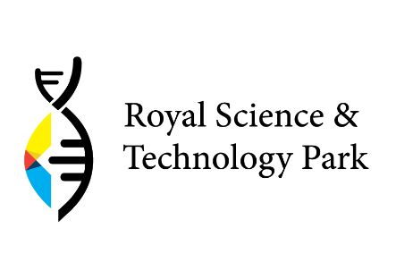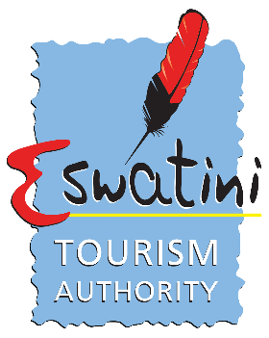

Destination Mobile App Challenge
Call for Applications
Deadline: 4 October 2021

A Joint Initiative of the Royal Science and Technology Park and Eswatini Tourism Authority

Background
The Tourism Industry is currently adjusting to the effects of Covid-19 and the subsequent lockdowns that have followed. This has meant that the industry has had to adjust significantly and embrace technology in an attempt to stay relevant and competitive. The importance of being adaptive and technologically cannot be overemphasized. This is especially true with tourism which is “consumed” at the destination, this has meant destinations now have to find innovative ways in which to not only attract tourists but to also encourage them to travel. Simultaneously, the current global situation has meant that the youth struggle to find jobs, whilst also encouraging innovation in the technological space.
The Kingdom of Eswatini is positioned strategically to benefit from this uptake in technology, whilst uplifting and involving the youth; one of the ways the country can do this is through launching a destination mobile app. This will ensure that tourists (domestic and international) “experience” the country at the touch of a button by downloading and using the app. In this regard, the Eswatini Tourism Authority (ETA) in partnership with the Royal Science and Technology Park (RSTP) have taken the initiative to improve tourist destination experience through designing and launching a destination mobile app that will be designed by the youth and will be launched on the 13th September 2021.

About the challenge
The ETA Destination Mobile App Challenge incentivizes the adoption of emerging technologies and encourages collaboration between technology developers, tourism service providers, the incubator and the ETA to modernize and grow the tourism industry in Eswatini.
The challenge aims to achieve the following objectives:
- To encourage and accelerate innovation in the tourism sector in Eswatini.
- To incentivize the adoption of the latest technology.
- To promote collaboration in the local tourism industry ecosystem.
- To reduce the costs of marketing for existing and new entrants.
- To obtain input to inform regulatory reforms to meet the demands of fintech environments.

Who are we looking for?
The competition is open to startups and teams of 1 to 5 that can offer innovative and viable solutions addressing the destination mobile app gap.
- All participants must be 18 years or older (18+) on the close date of the competition.
- Non-Swati nationals with permanent residency.
- Applicants must be owners of the innovation’s related intellectual property rights.
- The challenge is not open to ETA/ RSTP and partners’ staff members and their immediate family members.

Scope of interest
The ETA Destination Mobile APP Challenge invites technology startups to come up with innovative, novel, exciting, impactful and viable solutions for the listed themes:
- Visitor Information Centers: Where can one find Tourism Information Centers in the country.
- Information on Attractions: What attractions are available to visit, entry fees and operating hours. Include distance from current location.
- Activities (LIVE): What activities are happening in the country (daily, weekly or monthly. Updated as and when information is received, to make sure that tourists are always kept in the loop.
- Accommodation (where, how and links to book or contact details): Show accommodation establishments by location and have links that will take you to the external establishment website from the app.
- Amenities by location (show what is close to me): Show what amenities are located and where these are located. One can check for these by current location or they can check the whole country (by region).
- Map of the country and a guide: A map of Eswatini. showing all the details such as road names and speed limits.
- Information of transport and times (What is available, when, link to that): Types of transport available around the country, and the current location.
- Tools: Currency converter, weather, country information.
- Visa information: Show the visa regime and countries that need a visa and those that are exempt.
- Based on previous selections: there should be a menu feature that shows favorites (based on places visited previously).
- Safety and emergency information; Covid-19, safety and police and hospitals/pharmacies.
- Packages: include packages (itineraries) of 2 days - 6 days in the country. Specials from industry (seasonal).

Judging Criteria
Submissions will be evaluated for creativity and novelty, technical sophistication and business merit. The judges are experts in the technology (IT) and tourism industry.
Applications will be judged on the following criteria:
- Human capacity – relevant skills, full-time commitment, evidence of reliability and commitment based on previous projects.
- Prototype of the product (minimum of alpha version) and designs/pictorial representation of planned technological development to demonstrate the full vision
- Robustness of the underlying infrastructure, feasibility of the front-end and back-end technology and effectiveness of the solution.
- Integration with other technologies, security and reliability of the technology and service.
- Scalability and impact on tourism marketing/ inclusivity of less known attractions.
- Time proposed for completion of prototype.
- Credibility of the startup – incorporated company, business bank account. Start-ups owned by the youth or with youth team members will be prioritized.

What is on offer?
Grand Prize: One (1) Winner
The winner will receive the following benefits:
- A cash prize of SZL 30 000, to help further develop the product. Terms and conditions for the prize money will apply.
- Service agreement post-delivery of the product.
- A business incubation program consisting of office space, business development services, technical advice and market entry support, worth over SZL 140 000 per year.

How to apply?
- All applicants are to submit application forms via e-mail from 13 September to no later than 23:59hrs, 04 October 2021.
- Application forms are available on the RSTP and ETA websites via https://rstp.org.sz/incubator/
- Winner will be notified by e-mail on 7th October 2021.
- Application forms and any other relevant material must be sent to the below e-address applications@itbi.org.sz
- For more information contact us at: applications@itbi.org.sz
Terms & conditions apply.
Challenge Timeline
Task | Description | Timeline
Launch | Project is launched officially. Media is present for coverage. | 13th Sept 21
Entry forms | Upload entry forms and TOR on the RSTP website.  Competition to run from 13th September – 4th October 2021. | 13th Sept 21
Publicity | Continue to cover the project in owned and paid medias. | 4 weeks
World Tourism Day | Make mention of the competition at the WTD event and highlight that a few more days remain until competition closes. | 27th Sept 21
Competition closes | All entry forms are submitted and the committee to overlook these convenes. | 4th Oct 21
Selection | All entries are scrutinised, and eventual winner is selected. (5 Judges in total). | 3 days (5 – 7 Oct 21)
Winner is announced | The winner of the competition is announced at a media event to be held at the ETA Boardroom | 8th Oct 21

